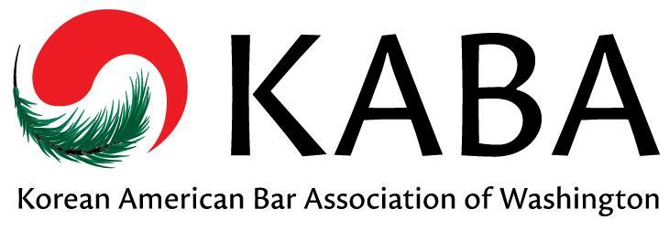 | Korean American Bar Association of Washington  Membership Form

MEMBERSHIP TYPE: ☐ New Member ☐ Renewing Member  ☐ Attorney  ☐ Law Student  ☐ Other Legal Professional:  CONTACT INFORMATION:  Name:  Title (if applicable):  Practice Area(s):  Firm/Company:  Address:  Phone:  Fax:  E-mail:  ☐ I do NOT want to receive announcements by email.  OTHER:  Law School:  Year Grad (or expct’d):  Languages Spoken:  KABA INTERESTS: (check all that apply)  ☐ Annual Banquet  ☐ Judicial Evaluations (min 3 yrs practice req)  ☐ Membership / Networking / Social Activities  ☐ Mentorship Program  ☐ Pro Bono Clinic  ☐ Professional Development / CLE  ☐ Website / Newsletter  ☐ Other Interests: |  | MEMBERSHIP DUES:  ☐ $50 Private Attorneys ☐ FREE Law Students  ☐ $35 Public Sector Attorneys* ☐ FREE Hardship Exemption**  Annual membership dues help to fund all KABA programs including student scholarships, the Korean pro-bono legal clinics, membership events, and community outreach efforts.  * Public sector attorneys include government attorneys, judges, prosecutors, public defenders, assistant attorneys general, legal services attorneys and attorneys for non-profit groups which qualify as 501(c)(3) organizations.  **Exemption available for attorneys who are currently unemployed.  MEMBERSHIP DUES PAID BY: (please check one)  ☐ Check: please make checks payable to the Korean American Bar Association of Washington & mail check with membership form to:  c/o Jennifer Sohn – Sohn Law PLLC  3006 Northup Way, Suite 100  Bellevue, WA 98004  ☐ Venmo: payment may be made to @KABA-Washington with membership form emailed to: kabawamembership@gmail.com  ☐ Credit Card: payment may be made using the links below with membership form emailed to: kabawamembership@gmail.com  Membership Dues - Private attorney  Membership Dues - Public Sector Attorney  DONATIONS:  Yes! I would like to support KABA and its programs!  ☐ $100  ☐ $50  ☐ $25  ☐ $____  www.kaba-washington.org  KABA is proud to be an affiliate of the National Asian Pacific American Bar Association (NAPABA).

